
RAMAIAH
Institute of Technology
USN | 1 | M | S

(Autonomous Institute, Affiliated to VTU)
(Approved by AICTE, New Delhi & Govt. of Karnataka) Accredited by NBA & NAAC with ‘A’ Grade

MAKE UP EXAMINATIONS – APRIL 2021
Program | : | B.E. : Electrical and Electronics Engineering | Semester | : | VII
Course Name | : | High Voltage Engineering | Max. Marks | : | 100
Course Code | : | EE73 | Duration | : | 3 Hrs

Instructions to the Candidates:
- Answer one full question from each unit.

 |  | UNIT- I
1. | a) | Explain different ionization processes in gases. | CO1 | (12)
 | b) | Derive an expression for the current growth in gases considering the secondary ionization process. | CO1 | (08)
2. | a) | What is time lag in breakdown? Explain how this is useful in designing the protective scheme. | CO1 | (08)
 | b) | In a parallel wire system placed in air, the radius of wire is 0.1 inch. Assume, smooth surface for the wire, pressure 910 mbar and temperature 30ºC. Calculate the corona inception gradient. | CO1 | (06)
 | c) | Determine the breakdown voltage for air gaps of 5mm and 7.5mm lengths under uniform field and standard atmospheric conditions. Also find the voltage if atmospheric pressure is 750mm of Hg and temperature 35ºC. | CO1 | (06)
 |  | UNIT – II
3. | a) | What are smoothening column and oscillating column? With neat sketch explain the working of 3-Stage Cockcroft Walton voltage multiplier circuit. | CO2 | (08)
 | b) | What is Van De Graff generator? Show that in this generator mechanical energy is converted into electrical energy. | CO2 | (06)
 | c) | Explain the breakdown of solid dielectrics due to internal discharges with relevant waveform. | CO1 | (06)
4. | a) | Derive an expression for the ripple of a high voltage Half wave rectifier with usual notations. | CO2 | (06)
 | b) | In a certain liquid dielectric, if there is only one metal particle suspended explain the phenomena that will lead to the breakdown of the liquid dielectric. | CO1 | (06)
 | c) | A ten stage Cockcroft-Walton circuit has all capacitors of 0.06μF. The secondary voltage of the supply transformer is 106 kV (RMS) at a frequency of 100 Hz. If the load current is 1 mA, determine (i)voltage regulation (ii) the ripple (iii) the optimum number of stages for maximum output voltage (iv)the maximum output voltage. | CO2 | (08)
 |  | UNIT – III
5. | a) | Explain the working principle of resonant transformer and how is it advantageous over the cascade-connected transformers? | CO2 | (10)
 | b) | For the single stage impulse generator shown in the Fig.5(b), obtain an expression for the voltage across resistor ‘R’.  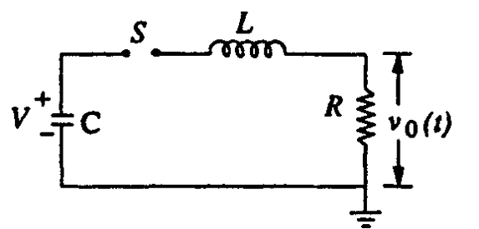  Fig.5(b) | CO3 | (10)
6. | a) | A 5-stage impulse generator has capacitors each rated at 0.63µF, 100kV. The capacitance of the test specimen is 5000pF. Determine the wave front, wave tail resistances and efficiency to produce a 1.2/50µs impulse wave using approximate formulae. | CO3 | (06)
 | b) | How are rectangular current pulses generated for testing purposes? How is their time duration controlled? | CO3 | (06)
 | c) | An impulse current generator is rated for 90kW-s. The parameters of the circuit are C=53µF, L=1.47µH and the dynamic resistance=0.0156 ohm. Determine the time-to-front and the time-to-tail of the current waveform. | CO3 | (08)
 |  | UNIT – IV
7. | a) | With neat sketch explain high ohmic series resistance with microammeter method for the measurement of high voltage DC and also mention its merits and demerits. | CO4 | (07)
 | b) | Discuss the resistance potential divider for very low impulse voltages and fast rising pulses. | CO4 | (07)
 | c) | Explain the potential dividers for impulse voltage measurements. | CO4 | (06)
8. | a) | Explain the sphere gap arrangement for the measurement of high voltage and discuss the factors affecting the measurement. | CO4 | (10)
 | b) | Explain the Chubb Fortscue method for measurement of high voltage AC peak. | CO4 | (07)
 | c) | Explain the generating voltmeter principle for the measurement of high voltages | CO4 | (03)
 |  | UNIT – V
9. | a) | Explain the high voltage Schering bridge for the tanδ and capacitance measurement of insulation. | CO5 | (10)
 | b) | What are partial discharge? Discuss the method of balanced detection for locating partial discharges in electrical equipment. | CO5 | (10)
10. | a) | Explain different types of tests conducted on Transformers. | CO5 | (12)
 | b) | Discuss the types of tests conducted on high voltage bushings. | CO5 | (08)

****************

